Dorothy Benton, Azeb Kieda, Alex McCarthy, and Charles Lyding

Prof. Aldwairi

CS 377

10/27/2017

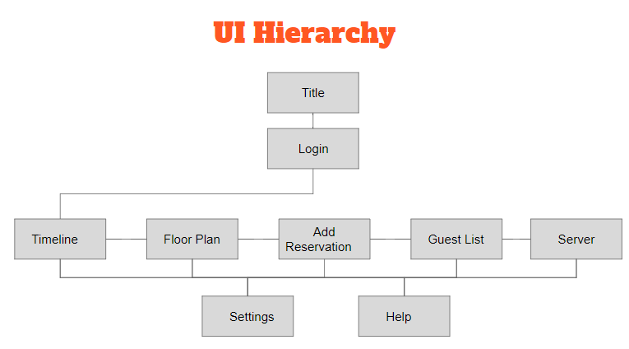

**1.Title screen:**

* Introduces program title
* Allows users to
  + Log in with existing username
  + Register a new username

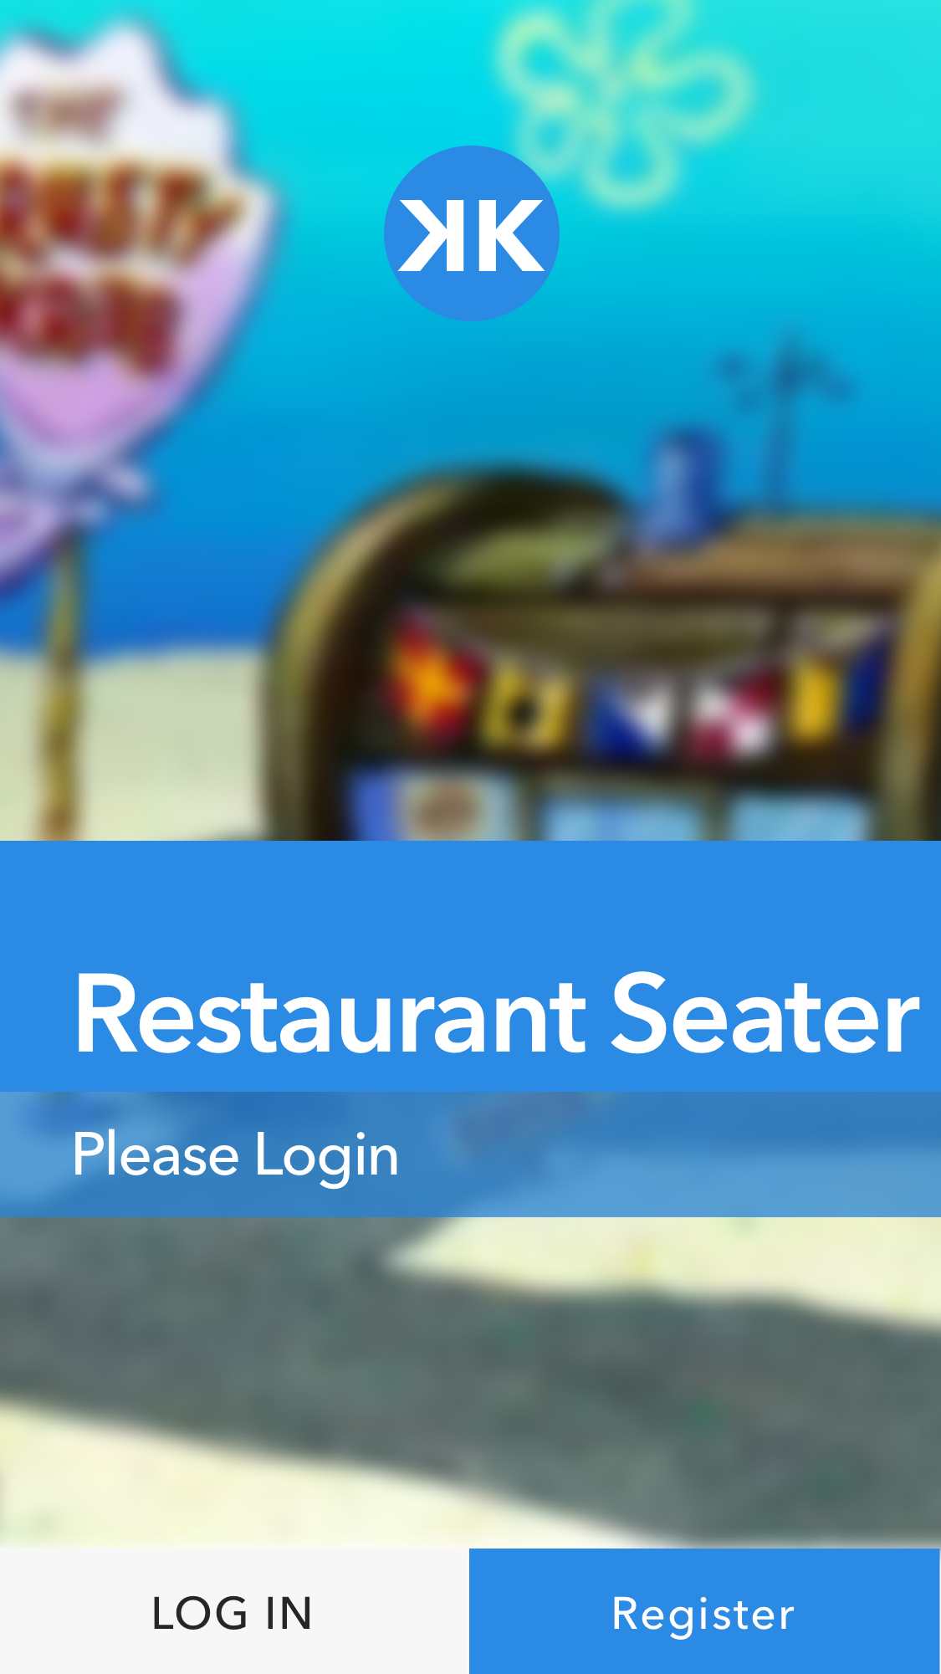

**2. Log in screen:**

* Users enter their username and password
* If incorrect, message will inform user

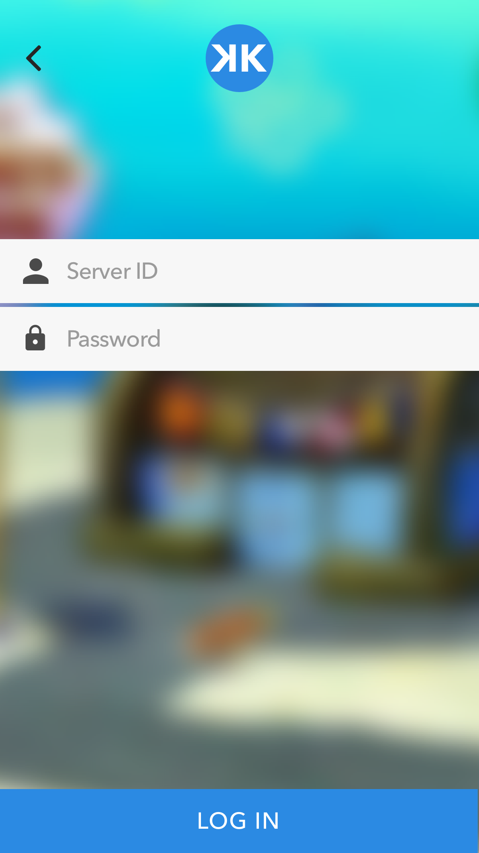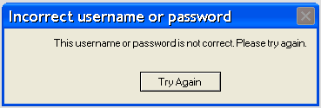

**3. Timeline:**

* Displays what time is a table available.
* Displays the number of guests.
* Shows how many people come during each 15 mins interval.

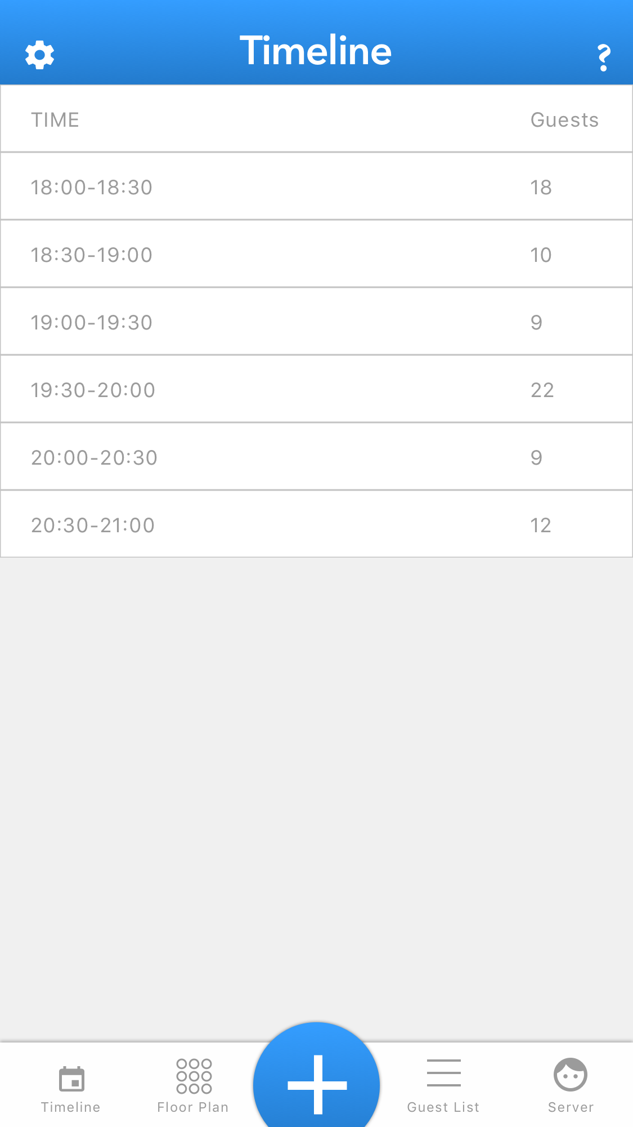

**4. Floor Plan:**

* Restaurant layout
* Multiple tables that show where parties are seated
* Tables numbered

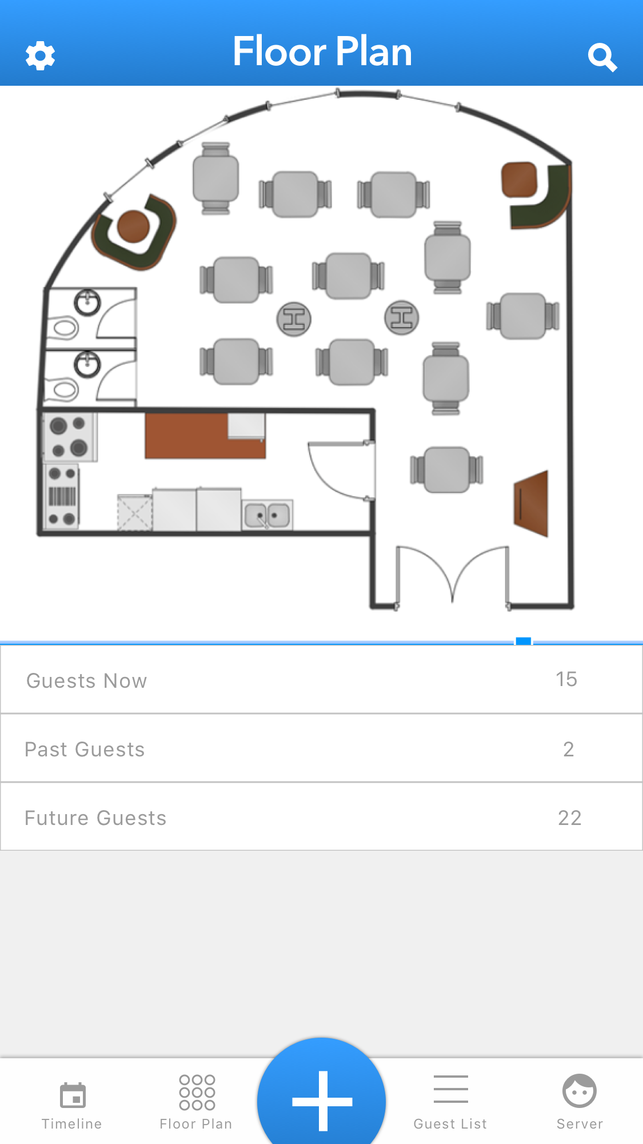

**5. Add Reservation:**

* Takes party first and last name
* Party size
* Reservation date and time
* Adds reservation

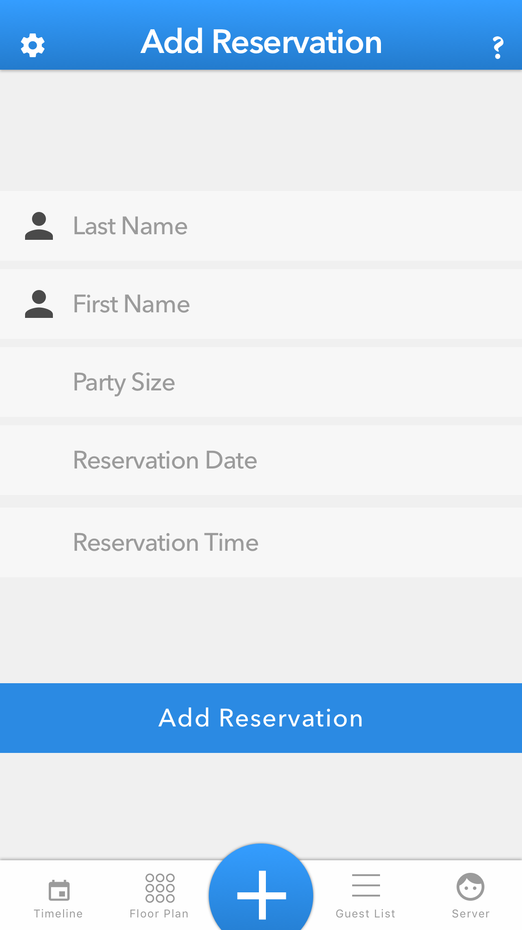

**6.Guest list:**

* Triggered by clicking Guest List
* Shows guest first name and last name
* Shows party size
* Shows which table is they are going to sit
* Items in the guest list will be removed if user selects to remove
* Items will be added when real time hits reservation time

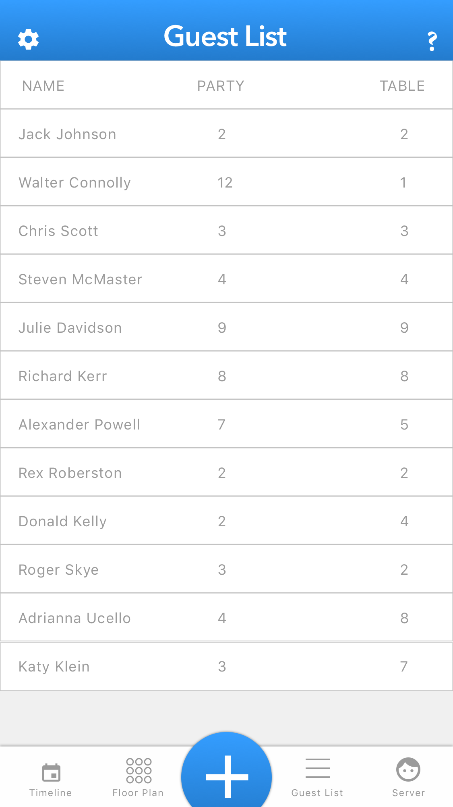

**7. Assign Server:**

* Allows users to assign servers to each table
* Server’s data will be updated with each new party at the table

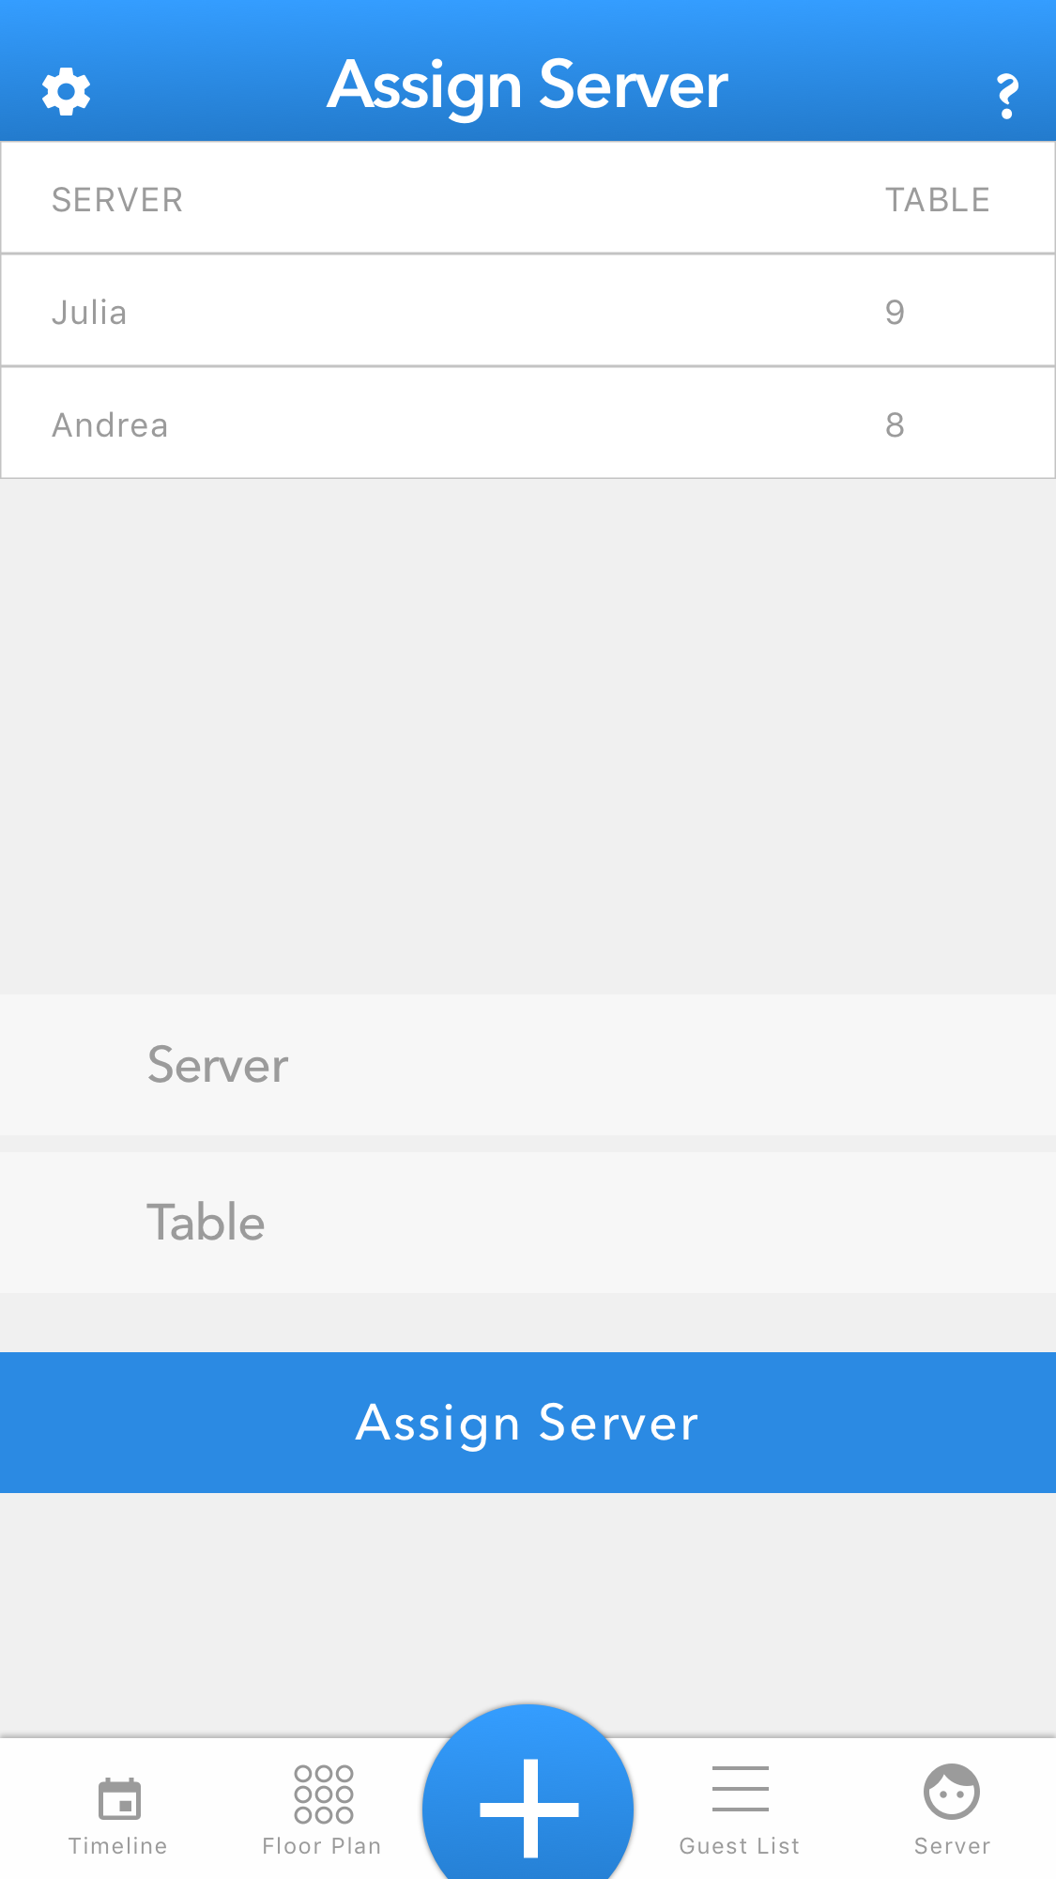

**8. Floor plan:**

* Restaurant layout
* Multiple tables that show where parties are seated
* Tables numbered

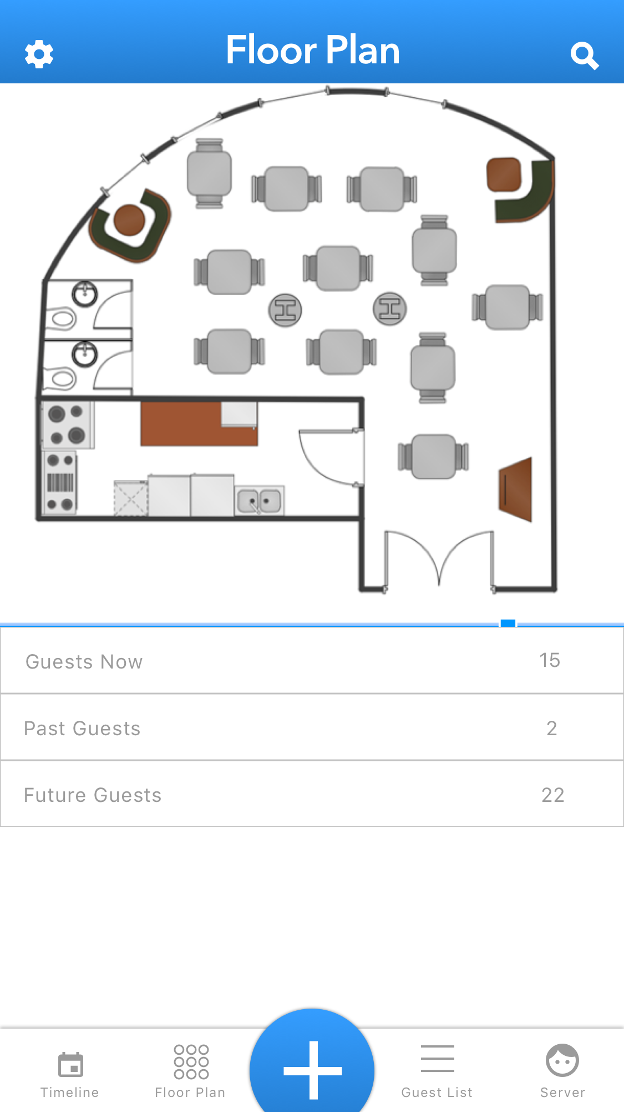

**9. Settings:**

* Select Language
* Color Blind Mode
* Settings affect all other UI frames

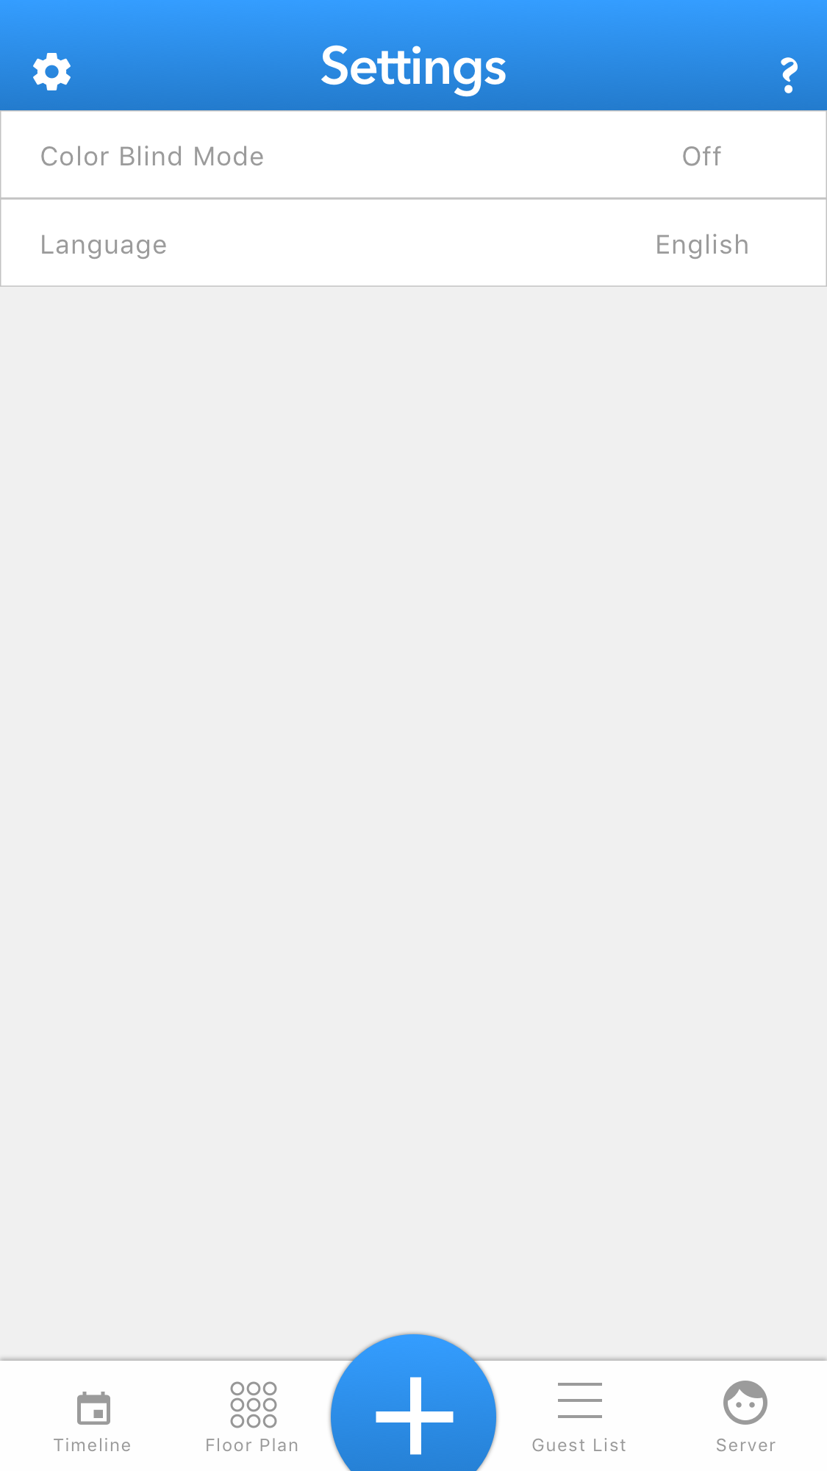

**10. Help:**

* Offers help instruction for each screen.
* Easy to understand.

